Baccus Winery Case Study
8/8/2026

Group A
Lane Dorscher
Chelsey Mcelhiney
Pedro Avila
CSD-310

Business Requirements
- Bacchus Winery produces four wine products: Merlot, Cabernet, Chablis, and Chardonnay.
- Bacchus Winery grows the grapes used to produce its wine.
- Bacchus Winery maintains inventory items categorized as either SUPPLY or PRODUCT.
- Supply items include materials and equipment used by the winery, such as bottles, corks, labels, boxes, vats, and tubing.
- Product items represent wines produced and sold by Bacchus Winery.
- Bacchus Winery tracks the quantity currently on hand for each inventory item.
- Supply items may have a reorder level used to determine when additional inventory should be purchased.
- A Supplier can provide one or more Items, and an Item can be provided by one or more Suppliers.
- Bacchus Winery tracks the unit cost of an item from each supplier that provides it.
- Bacchus Winery records Purchase Orders placed with suppliers.
- Each Purchase Order is placed with one supplier, and a supplier can receive multiple purchase orders.
- A Purchase Order can contain one or more Items, including the quantity ordered for each item.
- A Purchase Order can have one or more deliveries.
- Each Purchase Order Delivery records an expected delivery date and an actual delivery date.
- Supplier deliveries are reviewed monthly to determine whether suppliers are delivering on time.
- A Distributor can carry one or more product items, and a product item can be carried by more than one distributor.
- Only items categorized as PRODUCT are available for distribution and sale.
- A Distributor can place multiple Sales Orders, and each sales order belongs to one distributor.
- A Sales Order can contain one or more product items, including the quantity ordered for each product.
- A Sales Order can have one or more shipments.
- Bacchus Winery tracks the shipment date, delivery date, and status of shipments sent to distributors.
- Product sales are tracked by item so the owners can determine which wines are selling well and which are not.
- Bacchus Winery records information about each employee, including the employee's name and job title.
- Each Employee can have multiple Time Entries.
- Each time entry records the work date and number of hours worked by an employee.
- Employee work hours are recorded for payroll and reporting purposes.
- Employee hours must be summarized for each of the previous four quarters.
- The winery must be able to report on inventory, purchase orders, supplier delivery performance, product distribution, product sales, shipments, and employee hours.

Relationships
- A Supplier can be associated with many Items through SUPPLIER_ITEM, and an Item can be associated with many Suppliers through SUPPLIER_ITEM.
- A Supplier can have many Purchase Orders, and a Purchase Order belongs to one Supplier.
- A Purchase Order can have many Purchase Order Details, and a Purchase Order Detail belongs to one Purchase Order.
- An Item can appear on many Purchase Order Details, and a Purchase Order Detail references one Item.
- A Purchase Order can have one or more Purchase Order Deliveries, and a Purchase Order Delivery belongs to one Purchase Order.
- A Distributor can be associated with many Items through DISTRIBUTOR_ITEM, and an Item can be associated with many Distributors through DISTRIBUTOR_ITEM.
- A Distributor can have many Sales Orders, and a Sales Order belongs to one Distributor.
- A Sales Order can have many Sales Order Details, and a Sales Order Detail belongs to one Sales Order.
- An Item can appear on many Sales Order Details, and a Sales Order Detail references one Item.
- A Sales Order can have one or more Sales Order Shipments, and a Sales Order Shipment belongs to one Sales Order.
- An Employee can have many Time Entries, and a Time Entry belongs to one Employee.

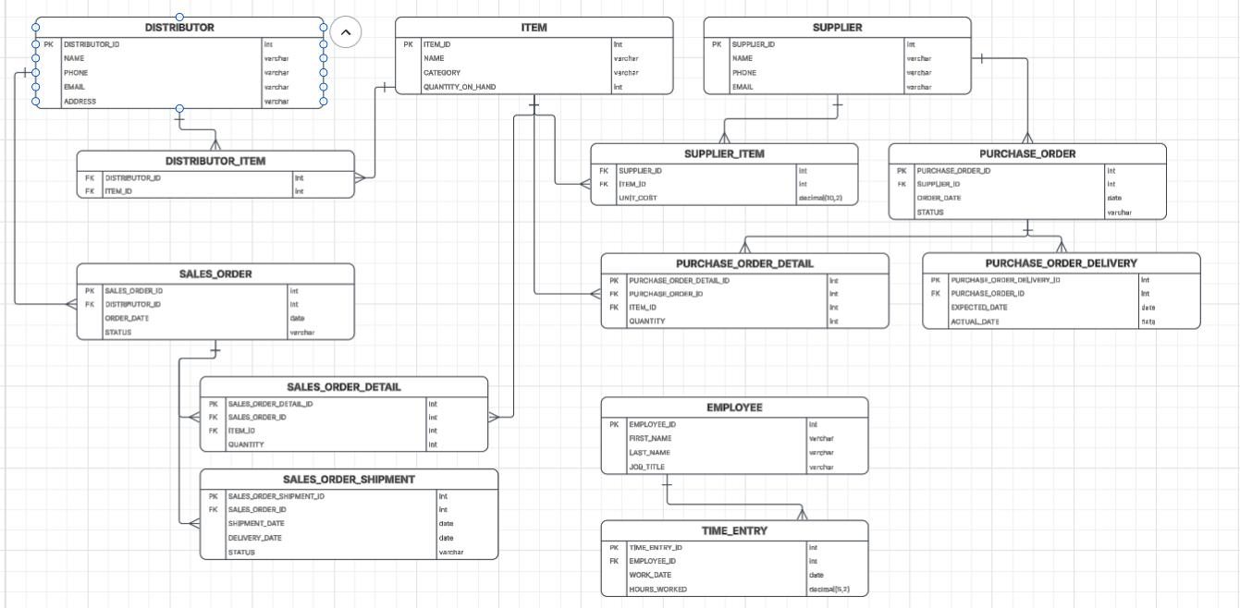
Entity Relationship Diagram (ERD)

